Executive Committee Members
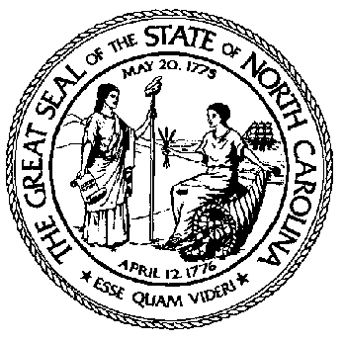
Malcolm Blalock, R.S. Mack Dendy, R.S.
Chairman Sylva, N.C.
711 Page Street Nilla Sloop, R.S.
Clayton, NC 27520 Sanford, N.C.
Perry Solice, Jr., R.S.
Terry L. Pierce Clinton, N.C.
Vice-Chairman Sheila F. Nichols, R.S.
1630 Mail Service Center Wilkesboro, N.C.
Raleigh, N.C. 27699 L. Layton Long, R.S. Lexington, N.C.
Ann C. Gilstrap, R.S. Burton R. Ogle, Ph.D.
Secretary-Treasurer Cullowhee, N.C.
3820 Bridges St., Suite A
Morehead City, N. C. 28557

NORTH CAROLINA BOARD OF SANITARIAN EXAMINERS
P O Box 610, Lumberton, NC 28359

Conference Call Minutes

July 13, 2006

The NC State Board of Sanitarian Examiners held a scheduled conference call meeting on July 13, 2006. Chair Malcolm Blalock called the meeting to order at 3:05 p.m.
Those present were: Malcolm Blalock, Terry Pierce, Ann Gilstrap, Nilla Sloop, Sheila Nichols, Layton Long and Janice Jones.

Conflict of Interest- Malcolm Blalock asked if there were any conflicts of interest. None were noted.

Janice Jones presented the following intern applications for the Board to consider:

Name County Degree University
David Stubblefield Randolph Co BS Environmental Health WCU
Lee Ann Garner Duplin Co BS Health Science Meredith College
Sarah E. Barrier Burke Co BS Environmental Studies UNC-Asheville
William Henry Banks NCDENR BS Natural Resources Mgmt UNC-Asheville
Mark Allen Prince R-P-M District BS Environmental Health WCU
Aaron David Bell Buncombe Co BS Environmental Health WCU

All transcripts had been approved and all required documents had been received.

Board Action – Motion made by Ann Gilstrap and seconded by Nilla Sloop to approve the RS Intern Applications listed above. All votes were affirmative, with Terry Pierce abstaining from voting on William Henry Banks.

There being no further business to discuss, the conference call meeting was adjourned.

Respectfully submitted,

Ann Gilstrap
Secretary-Treasurer

Date Approved _______________________

